Wireshark: Analyze network attacks
Scenario

A company’s website started showing connection timeout errors and became inaccessible to users. The issue was investigated using Wireshark packet analysis.
The captured network traffic showed a large number of TCP SYN requests being sent to the web server without completing the connection process. This caused the server to become overloaded and unable to respond to legitimate users.
You are required to analyze the traffic and identify the type of attack and its impact on the system.

Identifying the type of attack that may have caused this
network interruption
The issue is likely caused by a Denial of Service (DoS) attack, specifically a SYN flood attack.
The network logs show a very high number of SYN packets being sent to the server. These requests are not completed, which suggests the server is being overloaded intentionally.

How the attack is causing the website malfunction
Normally, a TCP connection is established using a three-step handshake:
- The client sends a SYN request to the server
- The server responds with SYN-ACK
- The client sends ACK to complete the connection
In a SYN flood attack, the attacker sends a large number of SYN requests but does not complete the handshake.
This causes the server to:
- Keep many connections in a half-open state
- Use up its available resources
- Fail to accept new legitimate connections
As a result, real users are unable to connect, and the website shows a timeout error.

Security Impact
The attack caused server resource exhaustion, preventing legitimate users from accessing the website.

Figure 1: High volume of SYN packets detected
Shows abnormal traffic pattern indicating potential SYN flood attack.

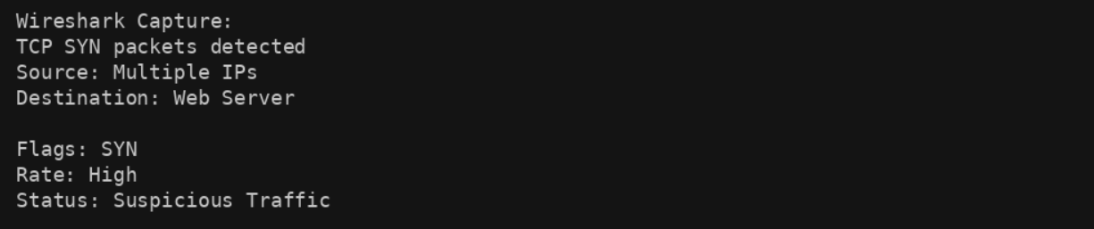

Figure 2: Incomplete TCP connections
Demonstrates how connections are not completed, exhausting server resources.

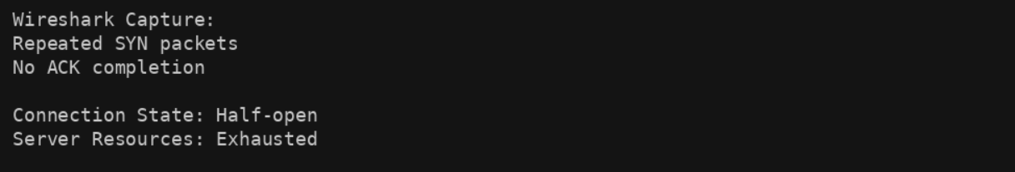

Figure 3: SYN Flood Attack Flow
Illustrates how repeated SYN requests overwhelm the server.

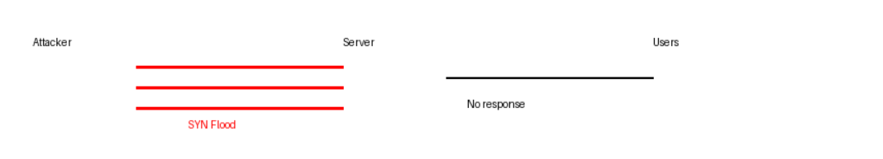

Wireshark TCP/HTTP log

